Grace Jiang

Information Warfare Final Project Draft 1

1. Introduce Sunny as an anecdotal lede, how she met the man and what happened including the trial.

2. She thought that was the end of it but you found her story being used to advertise illegal drugs on X

3. It wasn't just her being advertised, many people were using this man's victims to sell illegal things online.

4. Describe your total findings

She Testified Against a Rapist. Then She Became an advertisement.

Subtitle: From London courtrooms to Chinese social media, survivors of rape are finding their pain exploited by black-market ads spreading unchecked on X and illegal website.

Nearly two years have passed, but Sunny still remembers the details of that room and that night.

What started as a personal story of survival became a disturbing glimpse into a much larger online ecosystem. After Sunny testified against a serial rapist—Zhenhao Zou, 28 (20.02.97), of Churchyard Row, Elephant and Castle, was on Wednesday, 5 March found guilty of a total of 28 offences, including 11 counts of rape against 10 different women in a British courtroom, her trauma reappeared online — not through news stories, but in black-market ads using her case to sell rape videos, voyeur content and illegal drugs on X, formerly known as Twitter.

"If the police hadn't found me, I wouldn't think about this incident often. I would barely remember that it happened," said Sunny.

As survivors like Sunny try to move on, their stories are being hijacked to fuel an underworld of crime and misogyny which thrive in the algorithmic shadows of social media platforms with limited moderation, especially in non-English languages.

**THE SURVIVOR**

A trial at Inner London Crown Court, Zou was found guilty of a total of 28 offences, including 11 counts of rape against 10 different women. The above case is listed for sentence on June 19, 2025, according to K Arulsivayokan, an Admin Officer at Inner London Crown Court replied in an email.

However, only two of his victims, one of whom was the victim in two counts, have been identified so far. The other eight victims are yet to be traced. Police believe there could be another 50 further victims, with around half of the incidents being investigated by officers thought to have taken place in this country and the other half in China. Sunny is one of the two victims testified in a British court and accused a man named Zhenhao Zou of sexual assault. She had initially shared updates about the case on Rednote, a popular social media app in China, calling for other victims to come forward. When I reached out for an interview, she declined at first.

Later, she agreed to talk, but only through Rednote. Eventually, she added me on WeChat. We spoke remotely, and she would only communicate by words or voice. Her account had no real-name ID, just a cartoon avatar and the name “Sunny.” Since the incident two years ago, she’s become extremely cautious around strangers.

Officers discovered nearly 1,300 videos - but Zou insisted the sex depicted was consensual.

Whenever Sunny sees posts about sexual assault or videos related to Zou, she checks them. She said she used to be very afraid. Police had told her that Zou’s criminal method was consistent — inviting women to his home before assaulting them. The police also told her that they didn’t find evidence that he had uploaded videos.

“I was terrified the first few times,” she said. “But after watching several so-called leaked videos and realizing they weren’t mine, I felt a little better.”

In March 2025, the news of Zhenhao Zou — a Chinese PhD student convicted in London of drugging and raping 10 women went viral. During the trial, British police said they found more video evidence on Zou’s phone, suggesting there could be up to 50 more victims.

The story spread quickly on Rednote. Under one post, a user commented, “I already watched the rape video on X.” Others replied: “Where did you find it?” “Just search his name.”

Sunny checked the links herself. The videos didn’t match Zou’s apartment. Still, she felt disgusted. “They are using someone else’s trauma to sell illegal websites,” she said. “But it’s happening on foreign platforms. There’s nothing I can do.”

**ENTER THE ALGORITHM**

On X, searching for non-English criminal terminology yields numerous tweets and accounts. Even when searching for English illegal transaction keywords, there are still many non-English accounts blatantly conducting transactions directly on their profiles and in their bios.

To understand how much illegal content on X are spreading, I turned to Grok, an AI chatbot built by xAI. I used it to generate search terms.

I created a new X account using a Proton email and Tor Browser then ran A/B tests using both English and Chinese.

This table shows the number of accounts that can be found on X when searching the following keywords. For 'GHB', 731 is the number of accounts containing the word 'GHB', and 300 represents non-English accounts with drug selling or pornographic content on their profile pages. Due to X platform limitations, there are actually more than 300 non-English accounts, but after multiple attempts, loading fails and we cannot obtain an accurate account count.

Accounts found by searching the keyword 'Roofies' are almost all engaged in illegal transactions.

The Chinese keyword '春药' (aphrodisiac) also has more accounts than this number shows, but loading failures prevent us from getting an accurate count. Nearly all of these accounts are involved in illegal drug selling.

This table shows the number of accounts that can be found on X when searching for 'Voyeurism' and the Chinese term '偷拍' (hidden camera/candid photography). These accounts mostly feature adult videos and have extensive uncensored pornographic content on their profile pages. Within the 'Voyeurism' results, there are still many non-English adult content accounts.

Zou Zhenhao was convicted in the UK for rape and secretly filming numerous videos, which shocked the Chinese international student community. Some people have attempted to search for Zou's videos of sexual assault. This table shows the results found on X when searching in Chinese for 'Zou Zhenhao Voyeurism' and 'Zou Zhenhao Video.' Since the data was collected nearly two months after the incident, these results reflect what remains after X's cleanup efforts. During the initial news outbreak, searches yielded many more results. 'Illegal Content's tweets' refers to either accounts selling illegal services (surrogacy, prostitution, gambling), or content that exploits the news trend to lure users to illegal websites.

Searching “Zhenhao Zou” in English mostly showed news articles. “Zhenhao Zou rape video” led to more news coverage.

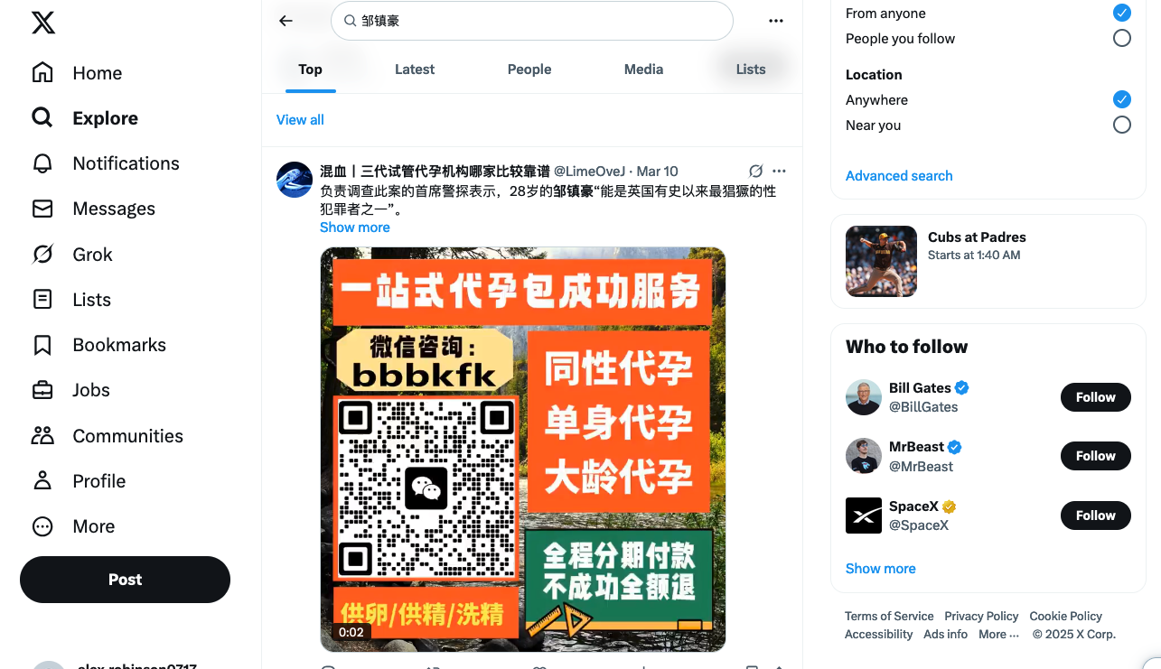

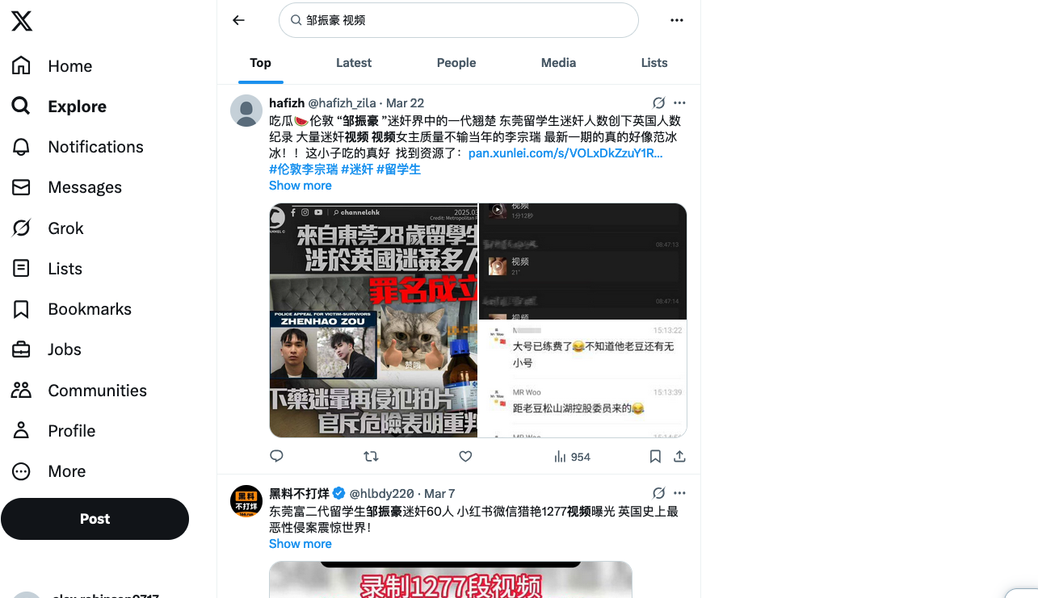

Using slang for date rape drugs turned up user accounts with drug names and contact info in bios. Some had background images with triazolam pills.

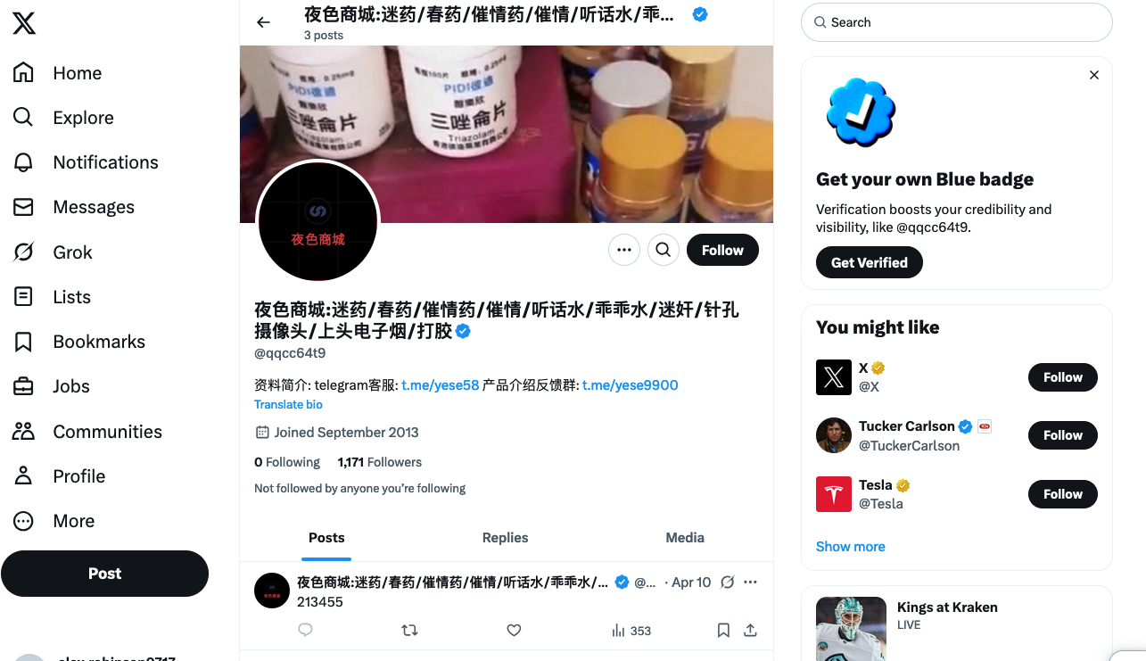

Searching “偷拍” (hidden camera) led to profiles selling voyeur content of restrooms, bathrooms, and schoolgirls. Many accounts included Telegram group links.

Many accounts promoted “young girls,” “kids,” “middle school students,” and “lolitas” as selling points. Most profiles contained Telegram group links and website links. Clicking on one random account, immediately jumped a sex video with content described as “masturbating student, so young.”

“Very common. Very common. Yeah. I mean, x is kind of given up on trust and safety. So we see a lot of lot of content on there that is concerning and but that that kind of tactic of kind of using other languages, runs through all the major platforms, for sure. I mean, there are gaps in in how they're enforced, or their ability to enforce kind of other language content that's not English,” said Marc Berkman, the CEO at Organization for Social Media Safety.

“I mean, hard is an interesting question. So you've got now a lot of it done through AI, which should be able to pick stuff up, yet still seems to fail fairly regularly, the more concerning issues get elevated to human moderators. But if you don't have enough moderators that are native, fluent in or at least proficient in the language at issue, uh huh, you're gonna miss some very serious stuff that even the AI will elevate, and that seems to be the issue we've seen that kind of spring up historically on with various issues, kind of election misinformation, historically in other countries, platforms have missed because it's not in the language of origin, drug trafficking, human trafficking, kind of a lot of these issues have not been caught by platforms because of language barriers, and they have not invested sufficiently in both automated and human mechanisms to protect against, it can be moderated for sure, just requires kind of investment and also kind of access for kind of children, access to safety tools for parents that a lot of the platforms block. But yeah, I mean, so what you'll see, I mean, because, because our works, our organization operates in English, but you'll see that generally people will use slang or drop letters or insert symbols to get around it. And you really have to know the language to know what you're looking at and know what you're searching for. And the same is true of any other language out there where they have ways to get around automated systems, they won't be able to pick it up as well. So however, I mean, but if you're watching these kind of these changes move in trends, because everyone is operating under those that want to kind of engage, certainly, an illegal behavior through social media. They're using the same trends for drug trafficking. They're using the same emojis. There is a really long kind of warning period where the stuff is out there, where the platforms just are so inexplicably slow to act. Yeah, exactly, however, like, I mean, they're explicably When you look at it from the profit motive, but yeah, but yeah. I mean, they certainly could act a lot sooner if they had the resources invested in the desire to” said Berkman.

“I mean, look, I they every user, every minute that every user spends on their platform. They make money from that. So there's always been a conflict of interest for the platforms between safety and profit at the end of the day. And so they're going to do just enough that it doesn't cause business issues. But I think what we're seeing and what they're banking on, is that people have fatigue. The world is complex, and the reputation has already taken a hit over the last five years. It has not acted profit, and so they're going to do the obvious. But if you have, if people start filling in symbols or emojis or slaying, you know, I think they're I'm not speaking. I'm speaking kind of strictly, in my own opinion, from what they're thinking, but they're thinking, we don't need to spend the extra time or money on this, and it's generating usable hours.” Said Berkman.

“they really gutted their trust and safety department. So we know that the matter of fact, kind of, in terms of the content, I mean, it's, it's anecdotally, gotten worse, yeah, based on our observations, gotten worse, not just stuff where, you know, some could argue, if they want to be the Free Speech platform, right, so they're not going to take down Any hate speech, any disinformation on health or politics, potentially, that's one standpoint, and consumers should know that. But we've also seen a rise in, you know, harassment, in fraud,” said Berkman.

“in theory, the text should make it better, right? But we're not necessarily seeing we're not seeing it quantitatively or anecdotally. The harms subside with kind of especially over the last two years. As you well know, they really should be able to kind of vet and remove dangerous content very quickly with AI, and I don't think we've seen kind of a change in pace.”said Berkman.

“I mean, the I think the question, a lot of those accounts are up and they facilitate people that are otherwise looking, I think, or whatever they're selling on there illegally. So it has made it significantly more accessible and convenient. It's more kind of a public health public safety issue to shut those down, the people that kind of stumble on them are potentially already looking for it anyways. So it's less about, I think the advice to those people now, for parents and kids looking it's a reason why you really shouldn't have a child on a platform like X. It is just not a safe place for a child to be. So parents need to understand that. But yeah, I mean, kind of public at large, the people that stumble onto those sites, I would say, in theory, we haven't tested this, but they're looking for that content. So interventions are more from a public health safety standpoint, yeah,” said Berkman.

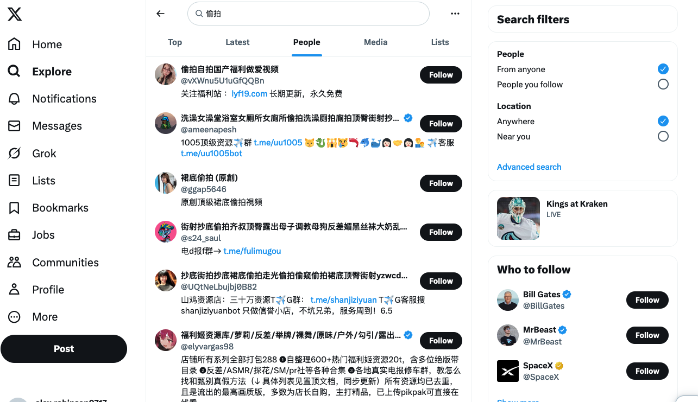

**On X, these illegal accounts typically direct potential customers to Telegram, WeChat groups, and illegal websites.**

**In some bot account bios, the website name "91" immediately raises red flags.**

**91Porn is a familiar site to most Chinese people—** it was previously China's largest homegrown adult self-uploaded video sharing platform, modeled after Pornhub.

Unlike Pornhub's free viewing + VIP privileges business model, 91Porn favors an invitation-only registration + paid value-added services strategy. They limit the overall user base by controlling invitation code purchase channels. **In China, "Clean Internet 2018" campaign was launched. Police arrested several most-followed video creators, including one known as "Mr. Qin." "Mr. Qin" was a married father who had studied abroad and formally worked as an executive at a Shanghai foreign enterprise. Before engaging in sexual relations with women, he would hide cameras to secretly film them. He then uploaded these videos to the illegal website 91Porn.**

**In June 2021, Beijing police cracked down on 68 locally registered 91Porn accounts, deleted 508 videos, and arrested 45 content creators.**

However, 91Porn has begun promoting itself on X and making a comeback.

**These websites publish free pornographic videos daily, including leaked footage of trending events in China. Whenever a major incident occurs domestically, especially related to sexual violence or conflicts, videos can be found on these websites within one to three days. However, the authenticity of the content is difficult to verify, and it's often just exploiting trending topics.**

**On these websites, you can find posts with titles containing women's names, home addresses, or workplaces. Each post features user-shared self-captured nude photos, mostly of wives, sex workers, bestiality, child pornography, and violent bloody content, including revenge porn and misogynistic material.**

**The entire website has 1,635 videos. It frequently uses terms like "bitch" and "sex slave" to degrade women. For videos labeled "underage" or "high school student," we cannot verify through the screen whether the young women in the photos are adults, nor do we know how much content constitutes more serious child pornography. Many posters claim they're uploading compromising photos of ex-girlfriends or ex-wives due to unresolved feelings after breakups.**

**In the video comment sections, nearly every video attracts derogatory comments like "I really want to fuck this bitch." Or solicitation comments such as "Anyone in Beijing want to hook up?"**

**"Explorer" videos refer to films where the recorder has relations with high-end sex workers, often secretly filmed. The recorder arrives at the room early to set up discreet mini cameras and livestreams to paying viewers. Many viewers secretly record the screens and resell the footage for 1,000 to 3,000 yuan.**

**Livestreamers easily earn tens to hundreds of thousands, while the sex workers who unknowingly become the stars receive only a fraction of that amount and bear the risk of being recognized in real life.**

**Besides privacy violations, the community features numerous videos of drugged rape. These videos show the assault of unconscious women or girls. The rapists (sometimes more than one man in the video) slap the victim's face, shout her name, and force open her eyelids to demonstrate she's in an unconscious state.**

**Experiencing sexual assault is tragic, and the resulting psychological trauma is already difficult to overcome. Having the drugged rape process repeatedly played on countless screens constitutes secondary and tertiary harm to the victims.**

**How do they profit?**

**Mainland China has a firewall on the internet, blocking access to search engines and social media like Google, X, Instagram, etc. Therefore, mainland Chinese users generally access these websites using virtual private networks.**

**Through IP address searches, the same IP address (154.207.77.23) connects not only to different routes leading to major pornographic websites but also offers two other categories of services: VPN provision and pirated movie websites. These three service websites are interconnected—the pirated video resource site promotes pornographic websites on its homepage with clickable redirects. Websites selling VPN apps also advertise pornographic sites and free pirated video resources. Meanwhile, the pornographic sites have pop-up windows selling hidden cameras, date rape drugs, and illegal sexual services in mainland China.**

**This creates a closed loop: attracting viewers by distributing voyeuristic videos of women, objectifying and insulting women in video titles and comment sections, then selling drugs for sexual assault, hidden cameras, or prostitution services through the website, initiating the next round of crimes.**

**The 91Porn site managers are very cunning. When Chinese technical departments attempt to block them, the website constantly changes domain names to evade technical blockades, redirecting servers back to the official site. The email addresses used for registration and the servers used are common publicly traded internet domain registries like Cloudflare and GoDaddy. The servers switch from China's Alibaba Cloud to Amazon AWS. Due to frequent domain changes, it's difficult to trace the people responsible behind this website.**

**Besides the resurgent 91Porn website, other pornographic video sites are learning from 91Porn to build their own gray areas. However, due to inexperience, they still leave traces that reveal how they gradually established themselves. The IP address can be traced through the website URL. Through the IP address, other domains under the same IP can be searched. One domain with a risk score of 100 in DomainTools raised suspicions. The email address used to establish this domain is a domestic Chinese email. Within six months of its establishment, this domain was first under an import-export trading company in Shenzhen, then transferred to a technology company in Haikou, then transferred its IP to Hong Kong via Alibaba, and later to a technology company in Shanghai. All three companies are small, with founding capital ranging from 1 million yuan to 10,000 yuan, and are either in continued operation or canceled status.**

According to relevant provisions of the "Criminal Law of the People's Republic of China" and the "Law of the People's Republic of China on Penalties for Administration of Public Security," prostitution, disseminating obscene materials, organizing the broadcasting of obscene audio and video, performing obscene shows, and providing conditions for the above activities are all illegal.

In October 2021, voyeurism was officially criminalized in Hong Kong—adding four new criminal offenses including "voyeurism," with a maximum imprisonment of 5 years. Since then, victims who report promptly are almost always taken seriously, and even if perpetrators aren't caught in the act, they can be found through the cameras that cover the streets.

However, in mainland China, the legal penalty for voyeurism is administrative detention for a maximum of 10 days and a fine of up to 500 yuan. What's often seen in Chinese news is that women who are secretly filmed have nowhere to turn for help and can only voice their grievances online.

**EVERYONE SAW, NO ONE ACTED**

Wanying Su, a Chinese graduate student in the UK, also worked as a private chef during her studies, accumulating many customers, including Zou. After the case broke, she volunteered to help other victims with evidence collection and translation. She now lives in China.

Su said she uses social media under a male relative’s phone number. While helping with the Zou case, she stumbled upon how easy it is to find rape drug ads and illegal groups online.

Once, Su clicked on a dating post on Rednote. Someone replied, saying it was a phishing scam. Then an account called “Dating Guide for Singles” invited her to join a group.

“On Rednote, if it thinks you’re a man, it pushes more and more illegal content,” Su said. “I didn’t even search.”

In one group, 400+ members talked about targeting rich Chinese women overseas and sleeping with Foreign students in China by using date rape drugs. Some sold step-by-step guides.

"They have channels both domestically and internationally," Su said.

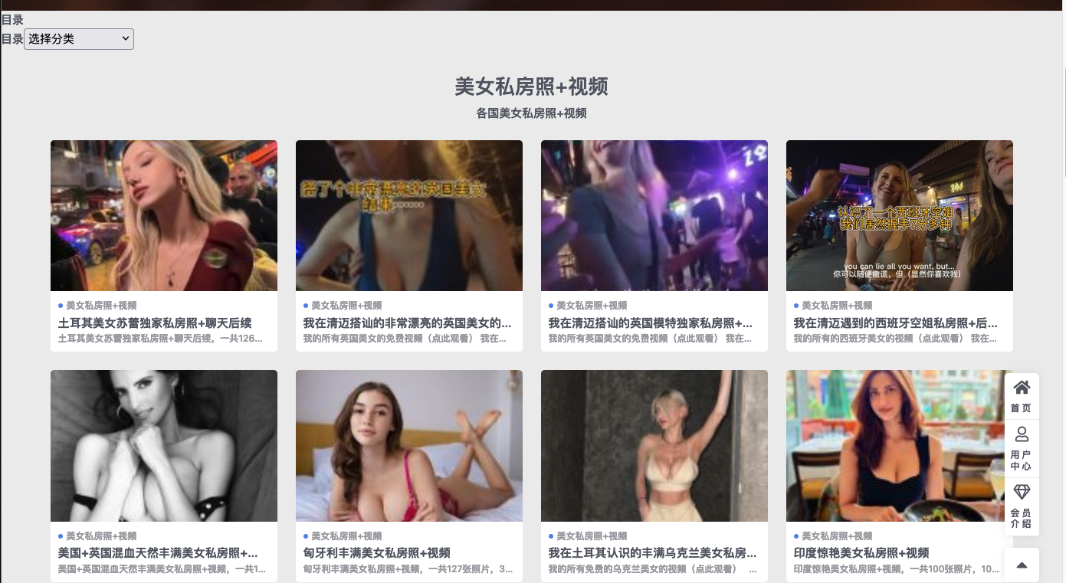

The group directed people to Chinese websites. One had a fake Beijing Public Security registration number which wasn’t in the official database.

One of the site admins wrote about his experience seducing foreign women. At the end of his post was a QR code asking for tips. Su scanned it — and it revealed the man’s real name and ID via Alipay.

Su called the police.

They filed a case. A Wuhan officer later told her they identified the man but couldn’t arrest him due to lack of witnesses. He asked her not to share the story.

Su also reported the case through China’s official government petition system. She listed: drug sales, obscene material, account manipulation, VPN use, Telegram groups. The report is still under review.

"The more I understand, the more frustrated I feel, like there's nothing I can do," Su said.

On X and on illegal websites, videos are still being updated daily. Trending stories are still being spread, not in the form of news, but as bait.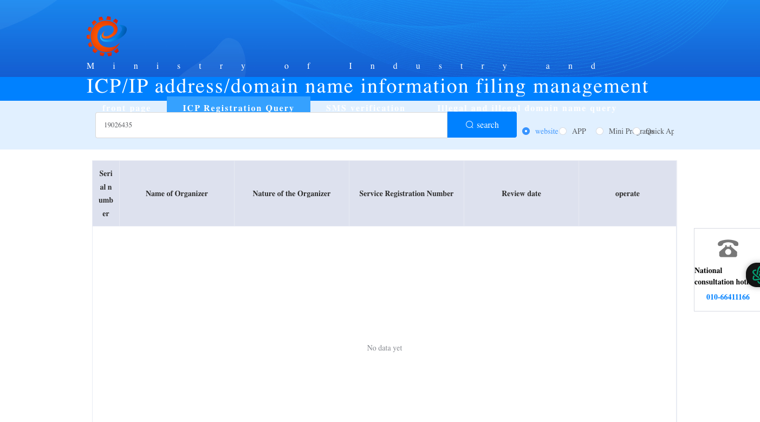

在X上，在非法网站上，每天视频还在更新。热点故事还在散播，不是以新闻的形式，而是Bait.

按照《中华人民共和国刑法》和《中华人民共和国治安管理处罚法》的相关规定，卖淫嫖娼、传播淫秽物品、组织播放淫秽音像、进行淫秽表演，以及为以上行为提供条件的，均属于违法行为。

2021年10月，偷拍在香港正式“入刑”了————新增“窥淫罪”等4项刑事罪行，最高监禁5年。此后受害者只要及时报警，几乎都会被受理，即便当场没抓到人，也能通过街上遍布的摄像头找到施害者。

但在内地，惩处偷拍的法律规定是行政拘留最多10天，罚款500元以下。而我在新闻中常常看到的是，女性被偷拍后求告无门，只能在网上控诉。

Domain share the same IP(154.207.77.23)-- *.pmfrwcdz.xyz; [www.pmfrwcdz.xyz](http://www.pmfrwcdz.xyz); bond.pmfrwcdz.xyz; buy.pmfrwcdz.xyz; among.pmfrwcdz.xyz; 52tv4.com (盗版视频) 首页连接着色情网站; atfu12.co（提供vpn）; p20.ypssitcg.cc（色情视频网站）; back.gtejajyp.cc（色情网站）; shcij.zvgkcnu.cc（色情网站）；same IP(154.207.77.24) cable.bbmwet.cc（色情网站）; h49rz1.apqrbf.cc(色情网站)；urx5.cc（成人tiktok app下载网站）；wikiwiki.dgwflz.cc（色情网站）；

VPN网站提供的是破解版app，app store搜索不到，但是得到了一个网站叫91app1.com—2021年5月25日创，IP地址最早在台湾。